
Methodological guide for
sectoral open data plans
August 2016

INDEX

- Introduction
  - Why a sectoral approach?
- Identification of potential and limitations in the sector
  - Barriers and challenges
- Agents involved
  - Players
  - Roles
  - Collaboration
- Sector analysis
  - Producers and consumers
  - Activities and usage studies
  - Data supply and demand
  - Indicators and monitoring
- Creation of a sectoral open data ecosystem
  - Proceedings
  - Techniques and tools
  - Operation

      - INTRODUCTION
There are different models for carrying out a governmental open data initiative: top-down, bottom-up or sectoral. Based on a common denominator, open data, all of these have distinctive characteristics and, therefore, different needs requiring diverse resources, as the following figure shows:
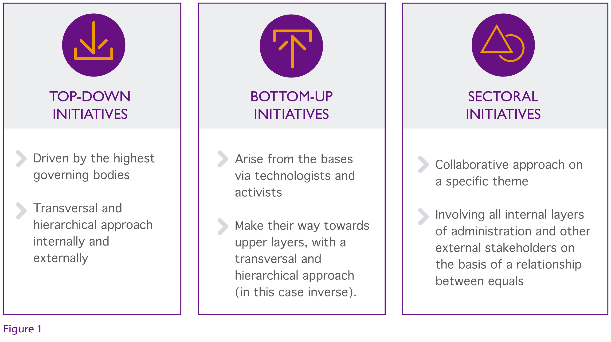
Figure 1. Typology of open data initiatives.

In this guide, we will focus on sectoral initiatives, analysing how they are organized to become an opportunity to construct open data according to concrete necessities of a specific sector; while we build alliances that allow a proactive publication of the data, characterized by a greater quantity and higher quality of the data.
This guide goes through the actors, actions and elements needed to implement these initiatives, although the particular way they are carried out will vary from sector to sector depending upon the specific case and the situation at the start.
An example of an application that shows the possible benefits, barriers, players involved and their roles as data producers and consumers, together with case studies for a specific sector, can be seen in the report by McKinsey which reviews the potential of open data in seven concrete economic sectors: education, transport, consumer products, electricity, extractive industries, health and household finance.

1.1 WHY A SECTORAL APPROACH?
The studies conducted by ONTSI show the existence of an infomediary sector and an active data market which generates a representative turnover and provides a number of qualified and quality job. Nevertheless, we are still far from the benefits initially predicted by reports such as MEPSIR and thereafter cited by other analyses such as the one carried out by Vickery. Moreover, these figures have been ratified recently by other reports, such as that sponsored in Europe by Microsoft.
Conclusions reached by different analyses and discussion boards indicate that the origin of the problem lies in the premise that data have no value on their own and, what is needed is to promote a dynamic ecosystem around data which enables the creation of solutions that contribute knowledge and business intelligence. It also appears that public entities need, apart from releasing data, to establish collaboration mechanisms to maximize the potential of those data. A sectoral or thematic approach may facilitate this task significantly in contrast with a general perspective because it requires fewer resources and focuses on more specific objectives.

To make a sectoral approach work, the ecosystem needs to be stimulated and, at the same time, special emphasis must be placed on the final needs of citizens, companies and users in order to prioritize which data are to be opened up, while looking for innovative open data models in intensive knowledge areas - such as retail, manufacturing, social media, population ageing, urban management, tourism, transport, food safety, public sector, health and medicine - which represent great opportunities.

2. IDENTIFICATION OF POTENTIAL AND LIMITATIONS
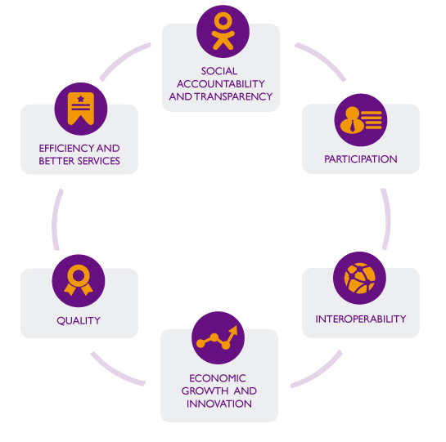
Before carrying out a sectoral open data initiative, it is necessary to analyse the potential benefits offered by the sector as well as the existing limitations.
Although the benefits shown by the analysis resemble the general benefits of any initiative that re-uses open data, we must deepen and personalize the study for the specific sector with concrete examples and applications.

Figure 2. Benefits of sectoral open data initiatives.

What are the main areas to explore?
- Social accountability and transparency: thanks to data sharing among all stakeholders involved in the value chain of the sector.
- Participation: by involving all stakeholders more actively in the design of added value services, building a community around the data which helps expand and improve them.
- Efficiency and better services: by contributing to the improvement not only of internal processes but of other services offered thanks to a deeper knowledge of the sector.
- Interoperability: by using open standards to share data in such a way that they can be combined with others, regardless of whether they come from the same sector or different sectors.
- Quality: by helping to improve the quality, reliability and depth of data through their open publication, which will impact in a positive manner internally.
- Economic growth and innovation: by providing bigger opportunities to experiment through the automated processing of data and its transformation into knowledge and services.
2.1 BARRIERS AND CHALLENGES IN THE SECTOR
The practical implementation of a sectoral open data initiative requires firstly a number of agreements to be reached in order to overcome the most common barriers that will arise.
The specific barriers and challenges that will arise should be analysed in depth for each specific case, but, in general, aspects such as those summarized below are frequently involved:


Cultural and institutional barriers
These are one of the most common barriers and most difficult to overcome, arising generally from fear of the unknown, and may also be produced in part by legal voids and loopholes. We need a cultural and organizational change that sometimes is quite profound. The more agents are involved, the more complex these barriers can be to solve.
In this case the biggest challenge is learning to network, share, evangelize, start with small pilots to illustrate with examples, help understand and verify results, etc.


Privacy and security
These depend mainly on the sensitivity of the sector in which we are working, but it is to be expected that there will be, to a greater or lesser extent, certain restrictions related to privacy and security to be taken into account and respected.
In this regard, a very important issue will be the possible side effects produced by combining data in a complex data ecosystem, which will certainly affect the privacy of information. In the most complex cases it might be even necessary to conduct external studies or audits to verify that appropriate responses are being given according to users’ concerns.
Here the main challenge we face is not to fall into the mistake of using privacy and security as a false argument to hide behind in order to justify the fear of change and limit access to data unnecessarily.


Legal barriers
These are not usually relevant as incompatibilities will not normally occur in the legal field among different actors from the same sector since the legal framework is usually shared among them all.
Nevertheless, if any kind of incompatibly does occur in this area, it can be a major challenge because legal frameworks cannot be easily and quickly adapted. In that case, alternative ways have to be found to make the initiative remain operational while a final solution is reached.


Organisational barriers
These arise because it is necessary to have the will and reach the necessary agreements to integrate multiple data resources, information flows, services, etc. within a sectoral initiative where different parties will be involved.
In this regard the challenge will be to avoid power struggles in the sector which hamper vertical initiatives.


Semantic barriers
These barriers need to be avoided in order to ensure that all actors involved speak exactly the same language in terms of entities, relationships, properties, models and data schemas, metadata, taxonomies and classifications, codes and identifiers, dictionaries, etc. Without this common language it will be very difficult for collaboration among all parties to be really effective.
In this respect, the greater and more diversified the sector in which the initiative will be implemented, the bigger the challenge will be.


Technical barriers
These limitations mainly concern the existence and/or the creation of necessary standards for formats, interfaces and communication systems in order to allow the automated exchange of information. This will help us guarantee the necessary interoperability to make data flow among the different agents involved in the initiative, avoiding the padlock effect produced by the use of proprietary or isolated systems.
The scenario related to the challenges posed will vary significantly depending on the level and degree of maturity of the standards existing previously in the sector. In the worst-case scenario, in which there would not be any grassroots level, the efforts required could be substantial.


Training and skills
The barriers consist in being able to provide the necessary training, education and mentoring to ensure that all participants in the initiative possess the appropriate skills. Here the goal is twofold. On the one hand, fulfilling the role allotted to each individual and, on the other hand, being able to analyse and use the data correctly to take advantage of them.
This time, the main challenge is caused by the number of profiles involved in the initiative and their diversity in terms of initial skills and future needs.
- AGENTS INVOLVED
In order to meet the needs of the sector and define the most appropriate strategy, first it is necessary to define the agents involved in the sectoral initiative. For this reason, it is important to identify - with full name - all stakeholders involved in the ecosystem of the sector in which we are working, including both current and future agents. .
Moreover, among all the identified players, it will also be necessary to detect those leaders who help motivate, build commitment and direct the activities while mobilizing other resources. These leaders will be distinguished by having a clear view of objectives and plans that help us achieve them. At the same time, they have the resources and/or contacts necessary for their execution.
3.1 Players
In the following list, major groups (and subgroups) of players involved in any sectoral initiate are described:

- Public administration, including every level: policy definition, departmental management and implementation.
- Non governmental civil organizations.
- Private sector.
- Academic and innovation sector.
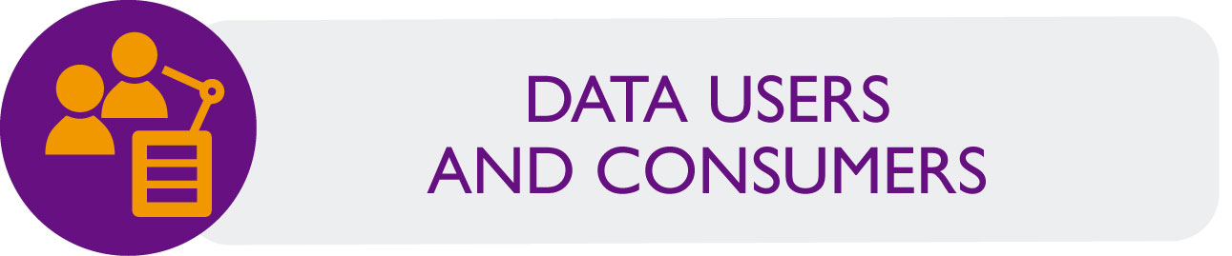
- Infomediaries and companies.
- Startups and innovative companies.
- Data professionals.
- Communications industry.
- Civil organizations, activists and citizens in general.
- Academic and innovation sector.
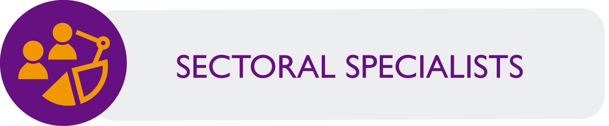
- Specialists in the sector: Transport, Education, Tourism, Health, Climate, Geography, etc.
- Specialists in data: consultants and experts in Open Data, Open Government, Linked Data, Big Data, Data Science, etc.
- Cross-disciplinary specialists: Legal, Economic, Social, etc.
3.2 Roles

Each player will perform one or various roles in the initiative, which have to be identified and specified in detail. Overall, the main roles played by the previous agents are the following:
Public sector: It represents the Administration as the main data supplier. It also provides experience related with the difficulties in information publishing and sharing.
The different organisms in the public sector will provide much of the raw material needed to create value by publishing data in response to the detected demand.

Private sector: Its function is to provide the experience and needs of the private sector related to the possibilities of exploitation of the data.
Its main role is to complete data availability; facilitate the conceptualization and creation of new applications and services based on public data that respond to the needs and current market trends, and enable collaborative arrangements for the publication of certain data in the appropriate formats.


Entrepreneurship: Would be responsible for business support and facilitate synergies and the transfer of knowledge to the various innovative business activities that may arise thanks to the initiative. Would also provide access to potential funding sources to help entrepreneurs develop their ideas and projects in the shortest possible time.

Civic organizations: These will contribute ideas, opinions and suggestions, helping to identify and make first-hand assessments of interest, necessities and possible market niches for new services and applications.

Data experts: Their job is to serve as facilitators and intermediaries, as well as direct the activities and participants in the new possibilities offered by data, the latest trends in the field, the application of best practices and guidance on tools available today.
Other national and European organisms: They will serve as a link with the existing data markets both in different national sectors and in the same sector from other countries in order to share experiences and identify best practices and global opportunities. Thus, they can also serve as active agents in collaborating and carrying out community projects of entrepreneurship.
In order to facilitate understanding of the above information, there follows a summary of the different player groups involved in this type of initiatives, including the roles they play.
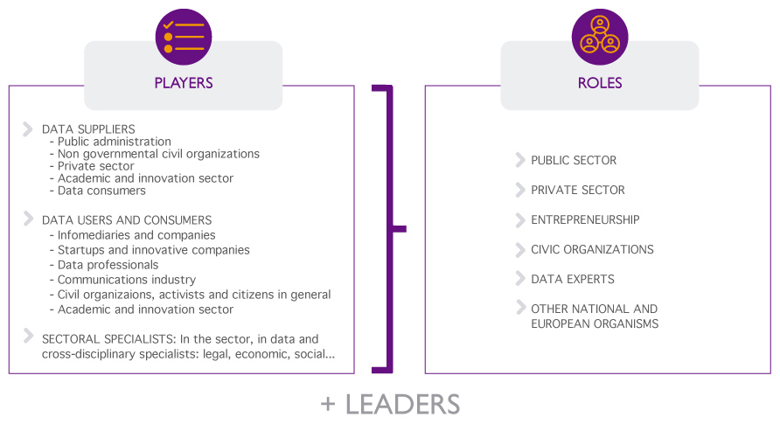
Figure 3. Group of players and roles in a sectoral open data initiative.

4.3 Collaboration
In parallel with the measures being carried out, if we want to exploit the full potential of the sector it is necessary to establish a mechanism for continuous dialogue and collaboration between the public sector, businesses and infomediaries.
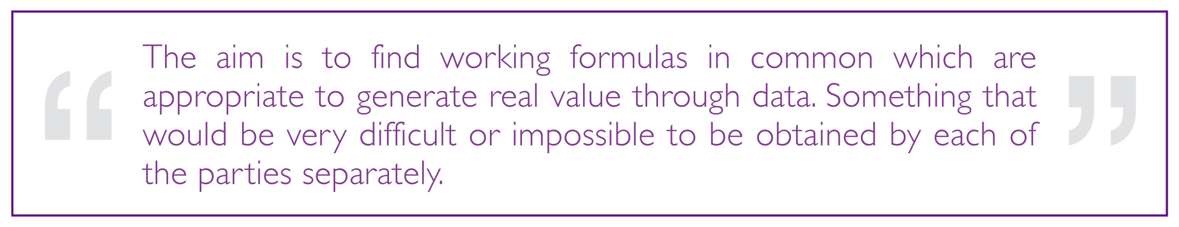
For this reason, the objectives of the new Digital Agenda for Spain include several measures designed for a new model of Administration that shares data with society, obtaining quality public services focused on the needs of citizens and businesses thanks to mechanisms of cooperation and collaboration.
The measures approved in this regard include:
- Development of a strategy of re-use that allows sharing and re-using projects, services and e-government applications developed by any Administration and establish forums to share experiences.
- Creation of tools needed to enable effective public-private partnership by establishing a relationship framework that contributes to boosting the ICT market, and by creating mechanisms to facilitate the creation and delivery of electronic services with the participation of other parties.

- ANALYSIS OF THE SECTOR
As we have seen in the previous section, in a sectoral initiative a number of very different players will be involved and each of them will have their own view of the sector, which, in a way, could be considered biased.
Therefore, one of the first and also one of the main tasks to be performed will be the detailed analysis of the sector that allows us to create a complete conceptual model of the ecosystem, which is taken as a common basis to organize the initiative. In order to develop such a model we should be able to answer a number of questions.
4.1 Producers and consumers


It is a question of defining who are the suppliers and who will be the customers. Different users (whether organizations or individuals) may have different needs and goals, so it is important to define clearly who is who and what their expectations are in each case. The definition of user profiles can help us carry out this task.
One must take into account that, depending on the sector, in many cases both roles overlap, with the same agent being able to work as a producer and user in certain cases. Usually when a producer also acts as a user, they will be denominated internal user against other users outside the organization.

4.2 Activities and usage cases

The same data can have very different uses depending on who the actor is that is using it at a certain point, what goals have been established and in which scenario he or she is.
A compilation of the most frequent usage cases in the sector will be very useful to contextualize the data and detect good practices. Additionally, it will be also useful to warn about the barriers, constraints and challenges that users face today.
Other issues that will be answered are the areas with the highest uncovered demand for data or methods to publish the information so that the real needs of users are met.
With this analysis we can know what the benefits are of publishing data, which will allow us, on the one hand, to promote the growth of supply and adjust it based on demand, and on the other hand, to establish the necessary mechanisms to validate to what extent these objectives are being fulfilled.
4.3 Data supply and demand
Sometimes a great deal of effort is invested in ensuring the greatest amount of data available or the greatest immediacy possible, but we forget to identify properly what the real needs of users are. We must treat users as if they were customers or consumers, and try to understand their needs and answer them efficiently, because if the data is not going to be used, it will have no value.
Experience has shown that managing the publication of data only from the perspective of supply is not sustainable in the medium to long term, and the way forward is marked by strategies directed towards data demand. Therefore, in addition to continuing to be proactive in publishing data, we must also adapt to the needs of users. One cannot use a one-way approach, or even bidirectional, because supply and demand should rather be seen as part of the same whole.
These needs should be evaluated not only in terms of specific datasets that are in demand in the sector, but also by analysing other variables such as the range and variety of formats and standards that we use to adapt to the specific needs of different users.
The ultimate goal is the definition of a complete inventory of data based on detected usage cases, including further information such as the current level of availability and the demand for new datasets.
4.4 Indicators and monitoring

A key to the success of sectoral initiatives once they are launched will be to have a reliable measure of their impact to help us understand what things are working and which are not.
This is why we need to implement an evaluation system which establishes the indicators and metrics required to assess the impact of open data policies applied and their usage. Thus, we will have a tool that allows us to assess which are the circumstances that can make data publication more effective. The evaluation framework should be common, known and shared by all concerned.
Ideally the indicators should not be exclusively quantitative (such as: number of visits, downloads, several analytical data, etc.) since these indicators alone do not reveal enough about how the data is being used or what users want but are not currently obtaining. Monitoring social networks can also be used to explore the scope being achieved, but not to understand the demand in depth. To ensure completeness some qualitative indicators should be included to help us verify the final impact in the sector (such as questionnaires, interviews, workshops, observation scenarios, etc.).
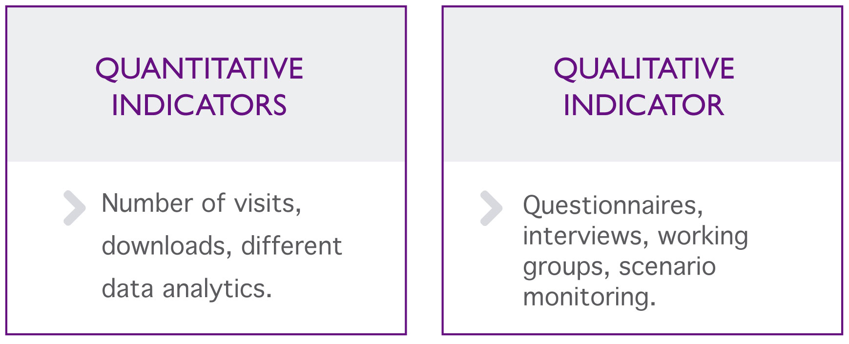

- CREATION OF A SECTORAL OPEN DATA ECOSYSTEM
Open data needs a balanced, healthy ecosystem in order to work. To feed that ecosystem we should be able to involve all individuals and organizations actively that, in addition to sharing interests in the specific sector in which we are working, also have the capacity to influence it.
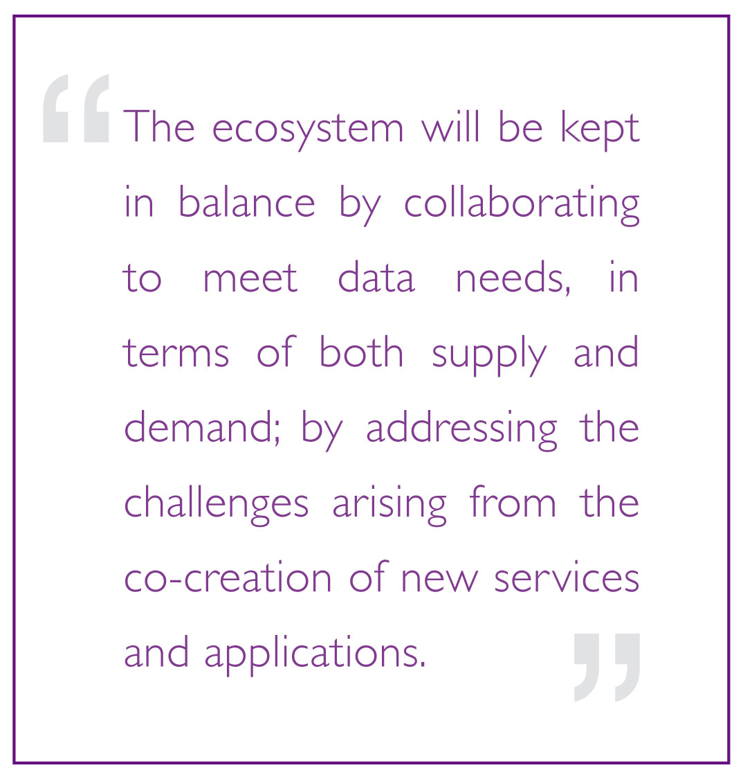
The goal in creating this ecosystem is to feed the formation of a virtuous circle that will lead to multiple benefits through its own operation, by generating: Increased demand for data as well as applications and associated services; greater incentives for infomediaries and re-users when creating such services; by making the benefits arising from the publication of data more obvious for managers thereof. The latter will, therefore, publish increasingly more data and will promote its availability... This will stimulate and restart the cycle again, with greater demand from consumers.
This would establish a shared culture of data in the sector that will be able to promote the necessary climate to define a common vision and objectives and obtain the cooperation of all parties to carry them out.

5.1 Actions
The actions carried out throughout the created ecosystem should give absolute priority to the improvements in the life cycle of the data in the sector, including:
- Data management: improving the mechanisms to collect and manage the data so that good practices from open data are included. The publication must be done in a collaborative manner among public bodies, private entities and the so-called third sector.
- Data availability: to make it not only possible but also easy for current and potential users to find the data. To do this, it is necessary to draw up inventories of the sectoral data and launch access points where the data is properly catalogued and available for users, following the good practices established.
- Access to data: the data repositories can use varied models and formats for representation and protocols for use. Different user profiles will require also different types of access and formats. As a general rule, the more flexible and diverse we are, the better we meet the user’s needs.
- Data quality: although we must always face certain problems of completeness, validity and accuracy of the data, we should be able to keep them within reasonable limits so that the data will continue to be useful without requiring a huge effort in cleaning and preparation.
- Interoperability: the value of the data is multiplied when we are able to combine it with other data (whether internal or external to the sector). Therefore, to enable several actors of the ecosystem to work together, the different challenges that arise in this respect must be addressed: data models and metadata standards, taxonomies, policies, tools, etc.
In order to define specific actions it will be necessary to start from the results offered by the initial analysis of the sector seen in the previous section. However, some key actions might be applicable in any situation, as in the following chart:
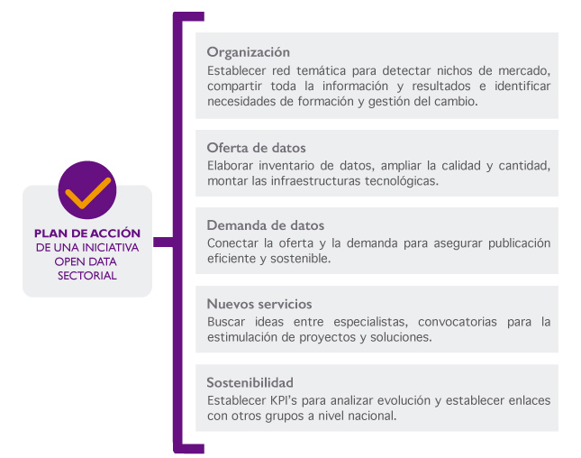
Figure 4. Action plan of a sectoral open data initiative.
Below are detailed each of the phases of the action plan of a sectoral open data initiative:
Organization
- Creating a thematic network to establish the necessary synergies to detect market niches and facilitate the transformation of data into useful services.
- Sharing all information and results among the different members of the network so that everyone can benefit from the experiences and know which have been successful and which have failed.
- Detecting the weaknesses and needs in terms of training and change management, developing appropriate plans to address them.

Data supply
- Developing a data inventory at sectoral level in which not only the existence of such data is included, but also the data flows between the players and how to interact through them.
- Expanding the quantity, quality and diversity of data available in the industry, making them also easier to be used by end users.
- Establishing the necessary technological infrastructure so that projects can find stable and updated versions of the data they need to create their services.
Data demand
- Directly collecting the needs and aspirations of potential users of the data to adequately influence future policies of data publication.
- Establishing mechanisms for the connection between data supply and demand by putting public officials in contact with companies and other entities that can help them achieve an efficient and sustainable publication of information that benefits all parties.
Value-added services
- Polling specialists in the specific area and their users in search of ideas for the re-use of data in the sector that meets the real needs.
- Supporting and promoting the creation of prototypes, projects and new businesses able to create value services from the industry data.
- Managing regular calls aimed at large companies, SMEs and newly created start-ups looking for projects that meet the previously identified needs.
Sustainability
- Conducting a campaign of re-use of information and establishing links with other active groups active in the field, both at national and European level to facilitate the integration and competitiveness of the sectoral re-use initiatives in the market.
- Defining a set of indicators and metrics to implement a framework to analyse the real impact obtained by the actions implemented and to compare it with the pre-implementation stage.

5.2 Techniques and tools
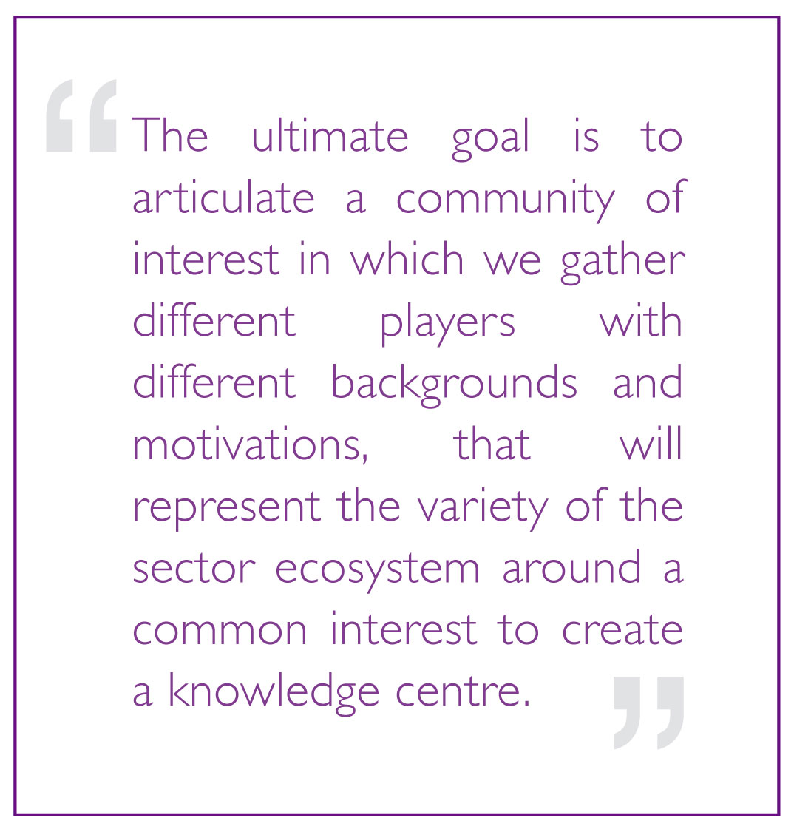
To carry out the objectives proposed it is necessary to combine a number of techniques and tools (both online and offline) which will be mainly aimed at facilitating the continued communication and collaboration necessary to combine the experience and expectations of all parties. It is advisable always to seek a balance between the different types of resources we use (documents, events, online and offline interaction, groupware tools, social media, etc.)
The specific tools and techniques to be applied in each case will depend mainly on the initial situation in which we find ourselves and the means we have at our disposal.
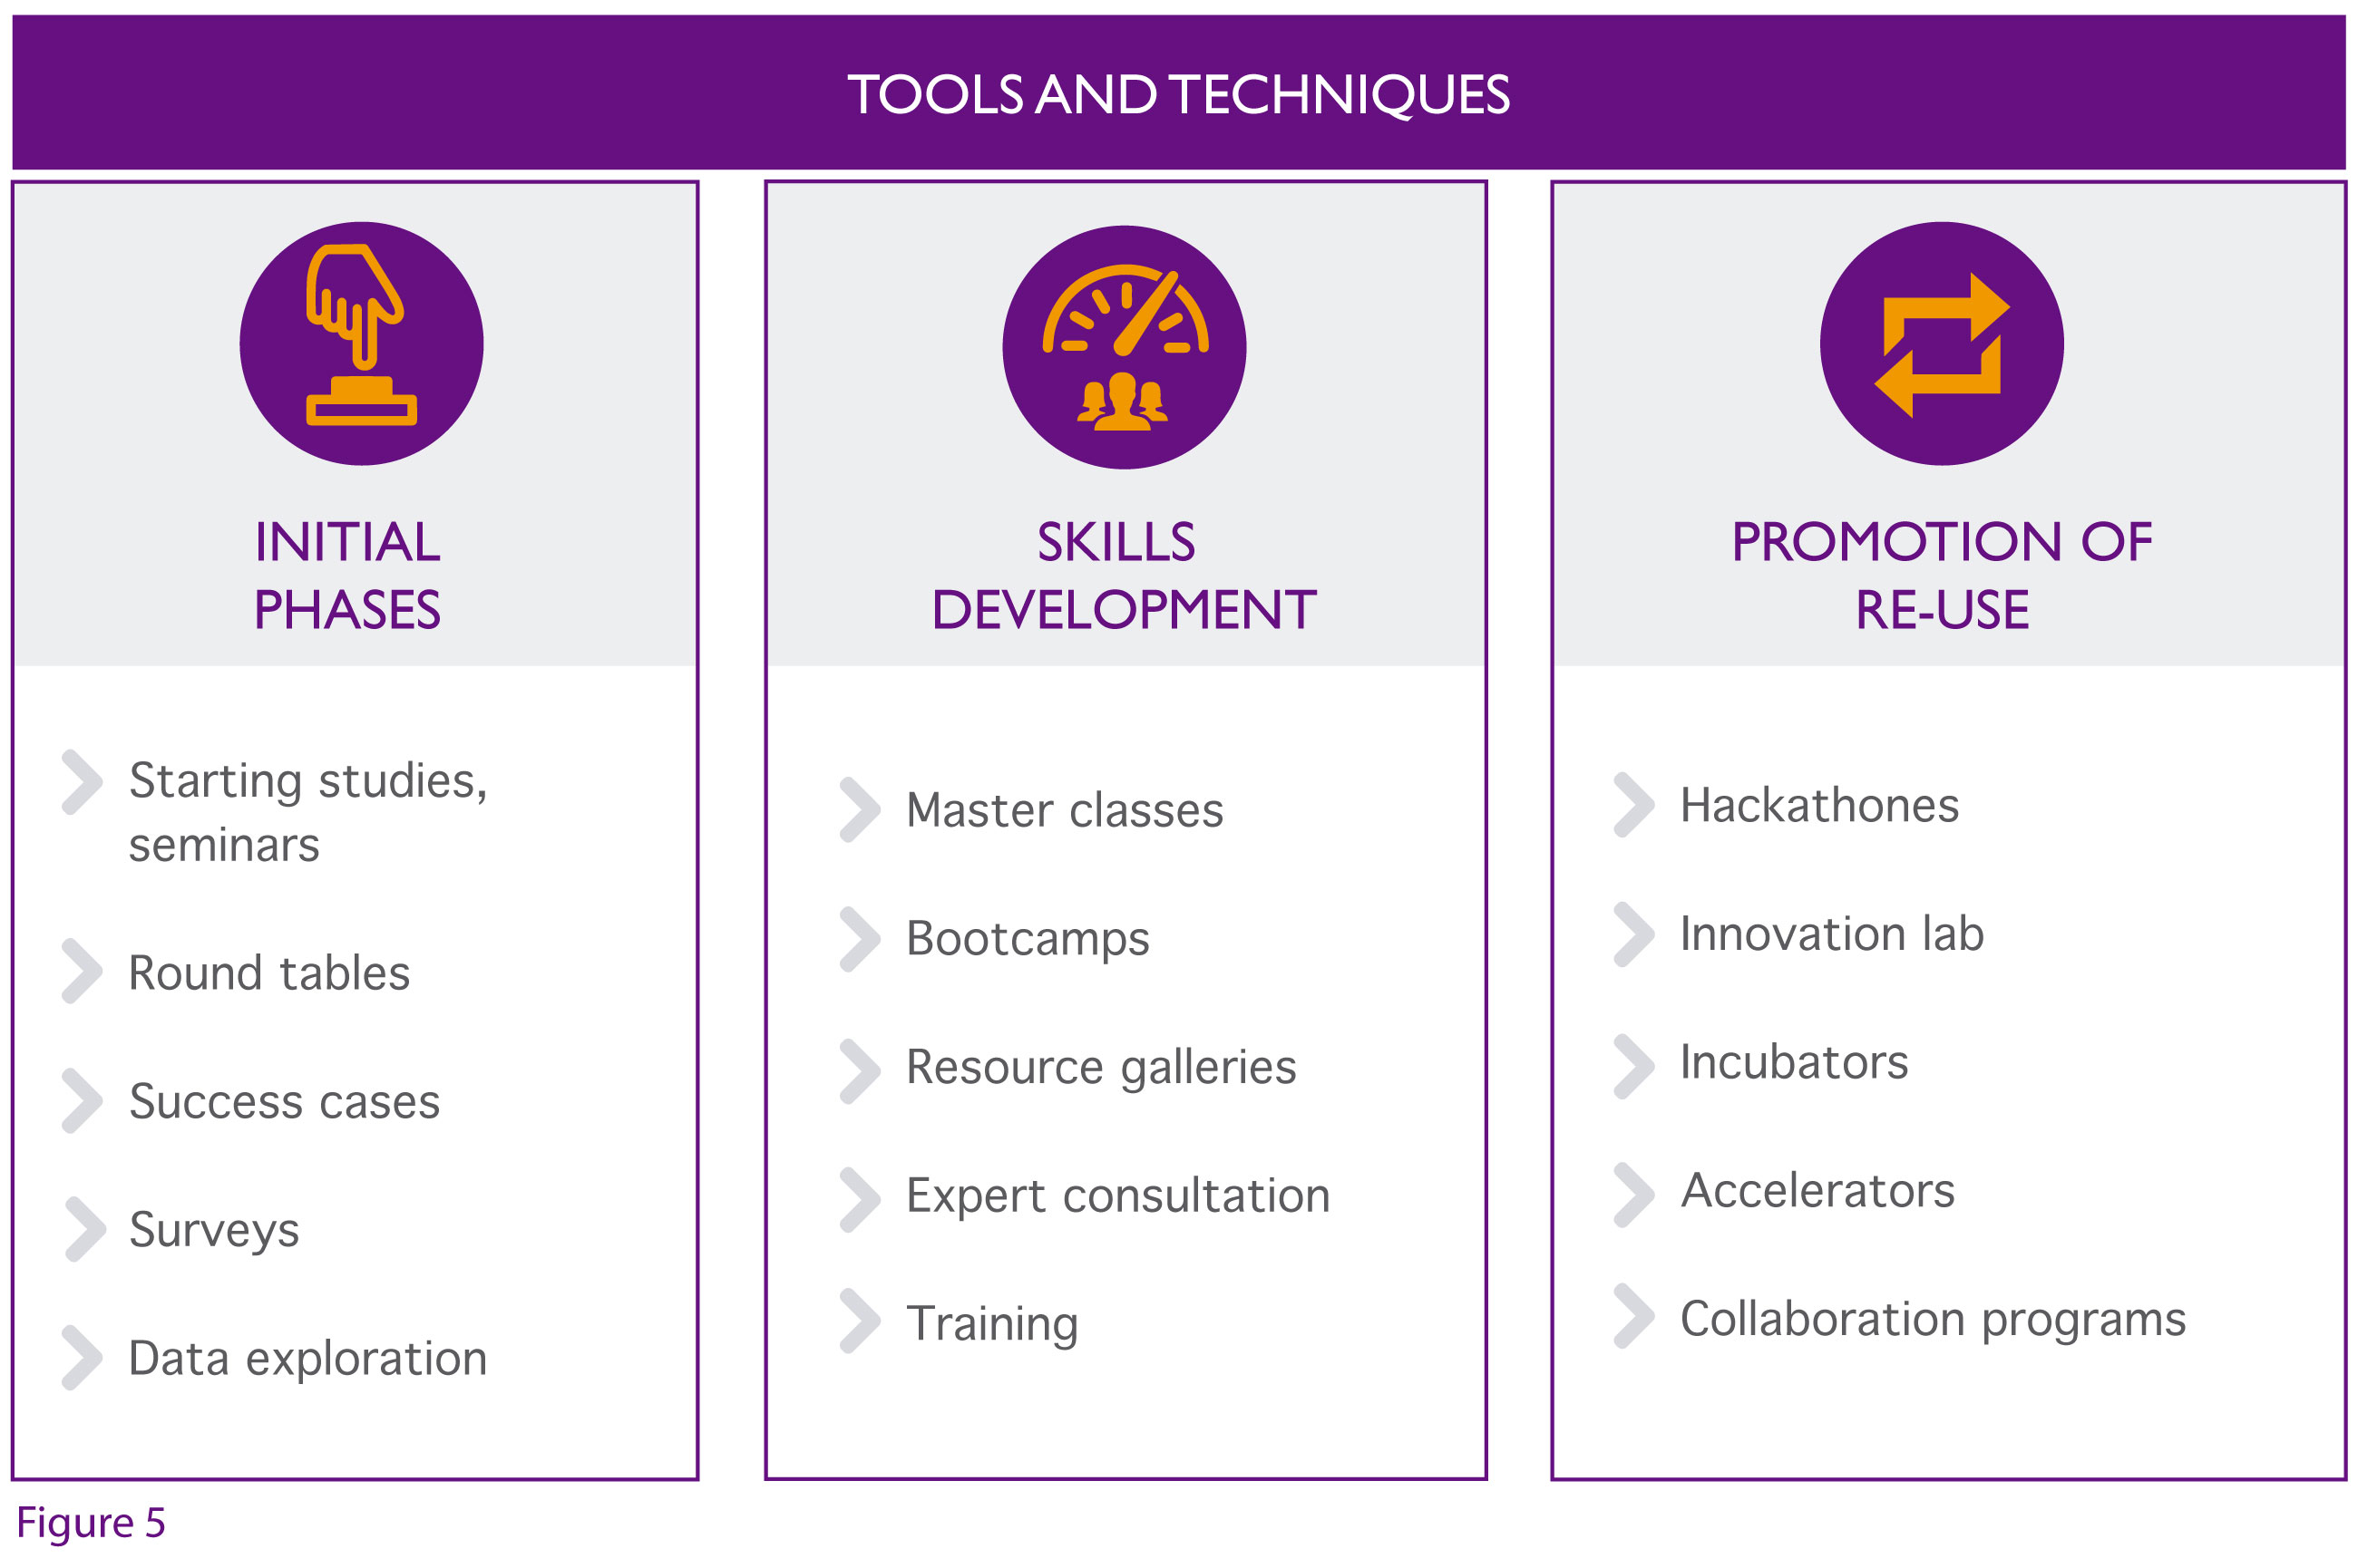 Figure 5. Tools and techniques of a sectoral open data initiative.
Apart from fostering the exchange of ideas and debate, such communities also make it possible to meet other actors with similar interests and promote relations between them for mutual benefit.
To facilitate the daily life of the community it is highly recommended to provide a platform which provides online support to the activity (through forums, mailing lists, document repository and resources, control panels, blogs, social media, newsletters, etc.). But it is also essential to enable the community to have the same activity and offline relationships through onsite activities. Among the most common and widely applicable options:
INITIAL PHASES
- Study of the state of the art: detailed report on the current starting state in the sector and organizations and individuals who form it, which serves as a tool to support decision-making during the strategic definition and objective analysis. An example is the study on the release of economic data by the World Bank.
- Seminars and round tables (or also online webinars): through which the benefits and experiences of open data are made known and generally disclosed. An example is the series of webinars on Open Government given within the framework of the Open Government Partnership.
- Description of business and success cases: to document the value of open data in real scenarios so that they serve as a guide for other agents interested in similar circumstances. An example would be the usage cases on public procurement developed by the Open Contracting Partnership.
- Data exploration (also known as data release or data expedition): whose main objective is to analyse and disclose as much data as possible on a given subject, and ideally in a way that it can be reused directly. To do this, a completely practical approach and specific action limited in time are applied. An example would be the data expeditions organized within the School of Data.
- Surveys (and micro-surveys): allow surveys of positions and views of a broad group of actors easily, quickly and with few resources, facilitating the subsequent analysis of the results. For example the survey to investigate the use of open data carried out by the Inter-American Development Bank.

SKILLS DEVELOPMENT
- Master classes: short-term (maximum one day) with theoretical and practical classes, taught by specialists with extensive experience and focused on responding to very specific aspects. An example would be the Ordnance Survey open data masterclass organized by the British Ordnance Survey Agency .
- Bootcamps: intensive and fixed-term bootcamps (2-3 days maximum) with a totally practical approach to develop the minimum necessary capacities when working with data. Contents may vary significantly depending on the target audience in each case. An example would be the d|Bootcamps organized to acquire skills related to data journalism.
- Resource galleries: an organized and updated online resource repository related to open data in the sector that can range from simple blog posts to scientific articles, tutorials, guides, videos and other multimedia content. An example would be the gallery of the Escuela Civio.
- Platforms for expert consultation: space in which open questions can be made in relation to the challenges of data management for other experts participating in the platform to give their views in this regard so that we benefit from the whole community knowledge. An example would be Stack Overflow for the programming world.
- Training courses (and teletraining): Complete courses in different subjects and aimed at different profiles that will be offered free and open to reach the widest possible audience. Courses will be preferably designed in a tutored and guided way, but they could also be done autonomously and via self-assessment. An example would be the Open Knowledge course organized by the University of Stanford.
- Continuous monitoring: to provide support on specific issues once the general training has been conducted. It can be articulated under different formulas depending on the resources available: follow-up meetings, action on demand, ongoing support, etc. An example would be the support service to public bodies carried out by datos.gob.es.

PROMOTION OF RE-USE
- Hackathons, contests and similar events: focused on solving specific challenges that have been previously raised by the co-creation of groups of people with different complementary specialities in order to test the feasibility and potential of new useful services. An example is the series of thematic open data challenges conducted by the Open Data Institute and NESTA.
- Innovation labs: physical and/or virtual spaces designed for the interaction of different actors, collaborating in applied research and development actions. An example would be the Government Lab @NYU.
- Incubators and accelerators: usually connected to hackathons and similar events, but they can also be held independently. Their aim is to help make the leap between the prototype and the fully functional service, providing guidance, additional training, logistical and financial support. An example would be the FINODEX project currently underway.
- Collaboration programs: in which over a longer period of time (usually from 6 months or more) different profiles (specialists, programmers, data scientists, etc.) are exchanged between some of the organizations and actors that form the sectoral ecosystem to facilitate experience and knowledge sharing. Efforts will be made on a specific objective which is usually some sort of project or product around data. An example would be the Presidential Innovation Fellows of the White House.

5.3 Functioning
The functioning of the sectoral community should be as flexible as possible, so the governing bodies should be kept to a minimum, promoting in general a function and mechanism of decentralized decision-making. One option is to establish an initial advisory committee within the community that is responsible for defining the general lines of action and ensuring the participation of key stakeholders, as well as organizing the planned activities and monitoring to ensure the success.
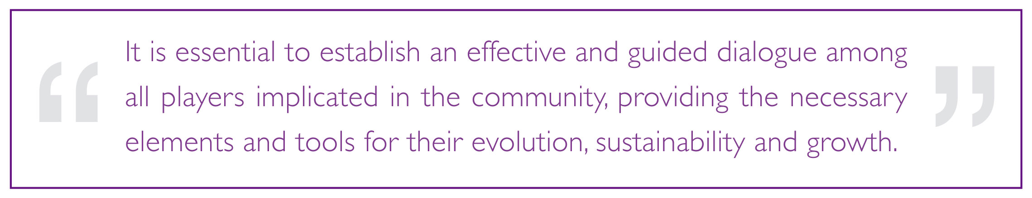
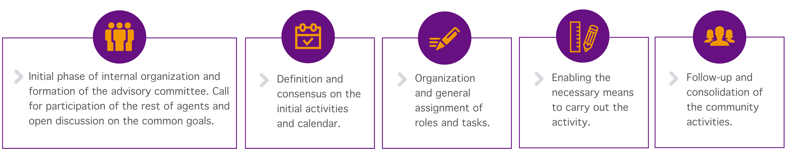
The implementation of the sectoral community requires that some of the entities involved (ideally more than one) lead the initiative and act as a facilitator, carrying out the first steps that consist of:
Figure 6. Steps to launch a sectoral open data initiative.
Subsequently each of the defined actions must be led by the different experts in the field to be treated, always with the support and advice of the members of the advisory committee.

REFERENCES
CRUE, Towards an Open University: Recommendations for SUE.
http://www.crue.org/TIC/Documents/Haciaunauniversidadabierta.pdf
NHS England and the Gov Lab, The Open Data era in Health and Social care.
http://images.thegovlab.org/wordpress/wp-content/uploads/2014/06/nhs-full-report.pdf
World Bank Group, Open Financial Data.
http://issuu.com/world.bank.publications/docs/open_financial_data
McKinsey, Open data: Unlocking innovation and performance with liquid information. http://www.mckinsey.com/insights/business_technology/open_data_unlocking_innovation_and_performane_with_liquid_information
Open Contracting Partnership, Community of Practice. http://pro-act.org/
Center for Technology in Government, Sharing Justice Information: A Capability Assessment Toolkit.
http://www.ctg.albany.edu/publications/guides/sharing_justice_info
Demos Europa and the Warsaw Institute for Economic Studies, Big and Open Data in Europe: A growth engine or a missing opportunity?
http://www.microsoft.com/global/eu/RenderingAssets/pdf/2014%20Jan%2028%20EMEA%20Big%20and%20Open%20Data%20Report%20-%20Final%20Report.pdf
The Aspen Institute, Information for Impact: Liberating Nonprofit Sector Data. http://www.aspeninstitute.org/sites/default/files/content/docs/events/psi_Information-for-Impact.pdf
GODAN network, Global Open Data for Agriculture and Nutrition: http://www.godan.info/
Open Knowledge Foundation, Open Spending: http://community.openspending.org/
IATI, International AID Transparency Initiative: http://www.aidtransparency.net/
U.S. Department of Health and Human Services, Health Data Initiative: http://www.healthdata.gov/
The National Archives, legislation.gov.uk: http://www.legislation.gov.uk/
The Open Data for Development Network: http://www.od4d.net/
The Open Data Capacity Building Game: http://goo.gl/upK8r3
World Bank, Open Government Data Toolkit: http://data.worldbank.org/open-government-data-toolkit
The Gov Lab, Realizing the potential of Open Government Data: a roundtable with the US Department of Commerce. http://opendata500.thegovlab.org/files/report-dep-of-commerce.pdf
The Web Foundation and IDRC, Open Data in Developing Countries: Emerging Insights from Phase. http://www.opendataresearch.org/sites/default/files/publications/Phase%201%20-%20Synthesis%20-%20Full%20Report-print.pdf

INDEX OF FIGURES

Figure 1. Typology of open data initiatives.
Figure 2. Benefits of sectoral open data initiatives.
Figure 3. Group of players and roles in a sectoral open data initiative.
Figure 4. Action plan of a sectoral open data initiative.
Figure 5. Tools and techniques of a sectoral open data initiative.
Figure 6. Steps to launch a sectoral open data initiative.

